Device: cuda
GPU: NVIDIA A100-SXM4-40GB
VRAM: 42.4 GB

PBT-V v5.6 Adapter:
Total params: 7,596,122
CalibrationMonitor: 0 params (rule-based!)
Classifier: +1 input (overconfidence_score)

==========================================================================================
Creating STL-10 Real Photo Sequences
96×96 RGB — 3× resolution of CIFAR-10
==========================================================================================
Downloading STL-10...
100%|██████████| 2.64G/2.64G [02:55<00:00, 15.1MB/s]
Total images: 13000
airplane (class 0): 1300
bird (class 1): 1300
car (class 2): 1300
cat (class 3): 1300
deer (class 4): 1300
dog (class 5): 1300
horse (class 6): 1300
monkey (class 7): 1300
ship (class 8): 1300
truck (class 9): 1300

Total: 1250 seq × 8 frames = 10000 frames
Train: 875 | Val: 187 | Test: 188

By type:
context_animal_cat : 100
context_vehicle_cat : 100
drift_safe : 150
gradual_drift : 200
normal_animal : 200
normal_vehicle : 300
sudden_anomaly : 200
preprocessor_config.json: 100%
436/436 [00:00<00:00, 54.6kB/s]
The image processor of type `BitImageProcessor` is now loaded as a fast processor by default, even if the model checkpoint was saved with a slow processor. This is a breaking change and may produce slightly different outputs. To continue using the slow processor, instantiate this class with `use_fast=False`.
Building tensor sequences...
Train...
Train done: 875 sequences
Val...
Val done: 187 sequences
Test...
Test done: 188 sequences

Image shape: torch.Size([8, 3, 224, 224])
Dataset ready!

==========================================================================================
Pre-computing Hidden States (DINOv2-Base on STL-10)
==========================================================================================
config.json: 100%
548/548 [00:00<00:00, 65.2kB/s]
model.safetensors: 100%
346M/346M [00:02<00:00, 322MB/s]
Loading weights: 100%
223/223 [00:00<00:00, 1093.46it/s, Materializing param=layernorm.weight]
DINOv2-Base loaded: 87M params

TRAIN...
Train 100/875 (8s)
Train 200/875 (15s)
Train 300/875 (21s)
Train 400/875 (28s)
Train 500/875 (35s)
Train 600/875 (41s)
Train 700/875 (48s)
Train 800/875 (55s)
Train done: 875 seq in 60s
VAL...
Val 100/187 (7s)
Val done: 187 seq in 13s
TEST...
Test 100/188 (7s)
Test done: 188 seq in 13s

Hidden state shape: torch.Size([8, 12, 768])
Expected: [8, 12, 768]
DINOv2 unloaded, GPU memory freed

==========================================================================================
Loading v5.5b Weights + Fine-tune Classifier Only
==========================================================================================
Skipped (shape mismatch): classifier.0.weight

Loaded: 142 tensors | Skipped: 1 tensors
v5.5b Val: 99.6%

Fine-tuning classifier only (5 epochs)...
Epoch 0: Train 95.4% | Val 97.6%
Epoch 1: Train 98.1% | Val 98.5%
Epoch 2: Train 98.8% | Val 99.0%
Epoch 3: Train 99.2% | Val 99.3%
Epoch 4: Train 99.7% | Val 99.0%

Fine-tune complete! Val: 99.0%

==========================================================================================
Comprehensive Test + Ablation — PBT-V v5.6
==========================================================================================

Overall: 99.5%

precision recall f1-score support

SAFE 0.9968 0.9976 0.9972 1236
ANOMALY 0.9888 0.9851 0.9869 268

accuracy 0.9953 1504
macro avg 0.9928 0.9913 0.9920 1504
weighted avg 0.9953 0.9953 0.9953 1504

By Type:
context_animal_cat : 97.3% (112 frames)
context_vehicle_cat : 97.2% (72 frames)
drift_safe : 100.0% (248 frames)
gradual_drift : 99.2% (248 frames)
normal_animal : 100.0% (224 frames)
normal_vehicle : 100.0% (384 frames)
sudden_anomaly : 100.0% (216 frames)

Running ablations (Overall Accuracy)...

Configuration Overall
────────────────────────────────────────
Full (A+E+V+M+W) 99.5%
No A (no gating) 97.8%
No W (naive predict) 99.3%
No E (uniform Pi) 99.4%
No M (no memory) 97.1%

==========================================================================================
Calibration Analysis: Normal vs Adversarial Sequences
==========================================================================================

NORMAL (calibrated baseline) (76 sequences):
Fr UNSAFE sigma2 sig2_corr eps2 ratio overconf alert% V_ep
───────────────────────────────────────────────────────────────────────────
0 0.000 0.1980 0.1996 0.0365 4.91 0.0033 100.0% +0.015
1 0.000 0.1981 0.2042 0.0926 8.10 0.0121 100.0% +0.013
2 0.000 0.2000 0.2064 0.0908 8.75 0.0126 100.0% +0.023
3 0.000 0.2010 0.2068 0.0899 7.92 0.0116 100.0% +0.028
4 0.000 0.2022 0.2085 0.0896 8.12 0.0126 100.0% +0.040
5 0.000 0.2057 0.2121 0.0921 8.22 0.0129 100.0% +0.042
6 0.000 0.2058 0.2116 0.0876 7.84 0.0117 100.0% +0.050
7 0.000 0.1958 0.2024 0.0954 8.85 0.0132 100.0% +0.052

CONTEXT: Vehicle+Cat (mild adversarial) (9 sequences):
Fr UNSAFE sigma2 sig2_corr eps2 ratio overconf alert% V_ep
───────────────────────────────────────────────────────────────────────────
0 0.000 0.2151 0.2167 0.0416 4.88 0.0032 100.0% -0.018
1 0.000 0.2153 0.2216 0.0933 8.72 0.0126 100.0% -0.034
2 0.000 0.2037 0.2098 0.0989 7.82 0.0122 100.0% -0.093
3 0.000 0.2277 0.2342 0.0999 7.53 0.0129 100.0% -0.119
4 1.000 0.2085 0.2351 0.1456 10.98 0.0531 100.0% -0.375
5 1.000 0.2227 0.2293 0.1025 10.84 0.0132 100.0% -0.301
6 0.890 0.2288 0.2378 0.1134 10.74 0.0180 100.0% -0.212
7 0.890 0.2423 0.2509 0.1114 8.90 0.0170 100.0% -0.154

SUDDEN ANOMALY (moderate adversarial) (27 sequences):
Fr UNSAFE sigma2 sig2_corr eps2 ratio overconf alert% V_ep
───────────────────────────────────────────────────────────────────────────
0 0.000 0.2018 0.2033 0.0364 4.74 0.0029 100.0% -0.026
1 0.000 0.2022 0.2083 0.0894 7.54 0.0123 100.0% -0.049
2 0.000 0.2132 0.2190 0.0882 7.59 0.0115 100.0% -0.097
3 0.370 0.2054 0.2183 0.1171 9.73 0.0257 100.0% -0.226
4 0.741 0.2208 0.2357 0.1237 10.57 0.0299 100.0% -0.392
5 1.000 0.2281 0.2401 0.1251 9.16 0.0241 100.0% -0.488
6 1.000 0.2187 0.2272 0.1198 10.45 0.0169 100.0% -0.471
7 1.000 0.2224 0.2316 0.1197 9.09 0.0184 100.0% -0.461

GRADUAL DRIFT (hardest) (31 sequences):
Fr UNSAFE sigma2 sig2_corr eps2 ratio overconf alert% V_ep
───────────────────────────────────────────────────────────────────────────
0 0.000 0.2093 0.2112 0.0426 4.65 0.0037 100.0% -0.028
1 0.000 0.2096 0.2161 0.0911 7.35 0.0129 100.0% -0.064
2 0.352 0.2110 0.2231 0.1147 9.24 0.0243 100.0% -0.185
3 0.290 0.2081 0.2203 0.1179 8.86 0.0244 100.0% -0.224
4 0.590 0.2189 0.2360 0.1395 10.94 0.0342 100.0% -0.312
5 0.742 0.2167 0.2312 0.1299 9.70 0.0290 100.0% -0.347
6 0.903 0.2225 0.2365 0.1268 9.62 0.0281 100.0% -0.384
7 0.968 0.2174 0.2281 0.1276 9.41 0.0214 100.0% -0.396

==========================================================================================
Summary: Calibration Quality by Sequence Type
==========================================================================================

Type Mean_ratio Max_ratio Overconf Alert% Correction
──────────────────────────────────────────────────────────────────────
Normal 7.839 8.850 0.0112 100.0% 0.0056
Context (cat) 8.802 10.978 0.0178 100.0% 0.0089
Sudden anomaly 8.608 10.566 0.0177 100.0% 0.0089
Gradual drift 8.722 10.941 0.0223 100.0% 0.0111

PBT Predictions:
Normal: ratio ≈ 1.0 (calibrated) → FAIL
Anomaly: ratio > 1.0 (overconfident) → PASS
Anomaly: alert > Normal alert → FAIL
Correction applied more to anomalies → PASS

==========================================================================================
Visualization: Calibration Monitor
==========================================================================================
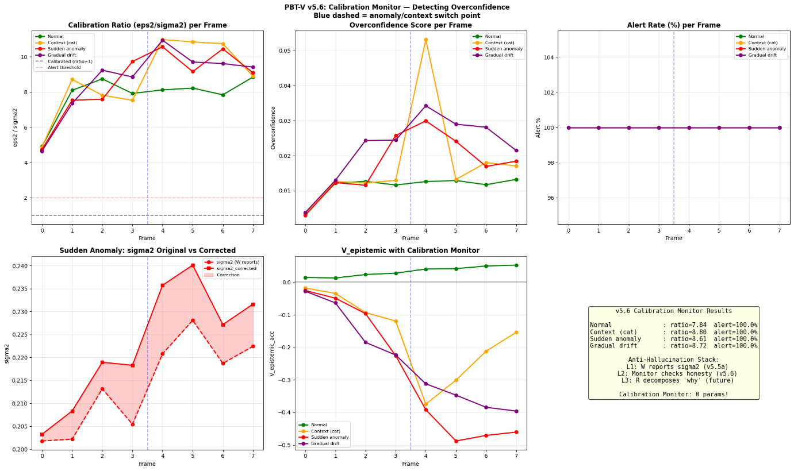
==========================================================================================
Per-Layer Calibration: Normal vs Sudden Anomaly
==========================================================================================

Layer ratio_normal ratio_anomaly delta Overconf?
──────────────────────────────────────────────────────────────────────
Layer 0 (Perception) 7.105 8.549 +1.444
Layer 1 (Perception) 22.789 25.863 +3.074
Layer 2 (Perception) 25.792 29.852 +4.060
Layer 3 (Perception) 6.751 6.325 -0.426
Layer 4 (Evaluation) 12.699 12.316 -0.383
Layer 5 (Evaluation) 6.355 6.882 +0.527
Layer 6 (Evaluation) 2.484 2.599 +0.115
Layer 7 (Evaluation) 3.875 3.974 +0.100
Layer 8 (Decision ) 3.220 3.380 +0.160
Layer 9 (Decision ) 2.099 2.437 +0.338
Layer 10 (Decision ) 0.588 0.783 +0.195
Layer 11 (Decision ) 0.316 0.332 +0.016

Saved: pbt_vision_v56.pth

==========================================================================================
v5.6 Calibration Monitor Analysis Complete!
==========================================================================================

